**Auto Electricity Bill Generator**

Samruddha kumbhar 11810204, darshan lohade ,pradyumn kulkarni

***Abstract*— The aim of auto electricity bill generator is to provide the consumer and supplier an easy way to monitor the power consumption regularly. Deployment of this project needs proper selection and implementation of a communication network depending on the features that the situation demands. In fact the design of the project depends on the requirements of the utility company as well as the consumers, this paper is about the algorithm of work flow and technology used in this project like thingspeak,this project calculate the electric unit and can show how much electricity is used**

***Keywords—thinkspeak, power consumption***

**Introduction:**

Electricity is one of the main source of energy , many corporation work to ease the calculating consumption of electricity , by calculating electric units one can ensure the damage and waste of it , this project gives a brief description about how using the proper methodology and implementation electric bill can be generated with man work , this can help government to calculate the individual electric units and generate bill according and if needed it can cut off the electricity accordingly without human need

**Implementation details:**

Important thing in IOT is connection of hardware with Internet. Hardware is something which code up and decode as well. We have low cost, high level programmable microcontroller ESP32 which is highly-integrated with in-built antenna switches, RF balun, power amplifier, low-noise receive amplifier, filters, and power management modules. **ESP32** adds priceless functionality and versatility to your applications with minimal Printed Circuit Board (PCB) requirements. Hybrid Wi-Fi & Bluetooth Chip. As per project we need Electricity meter, but we have used IR sensor as alternative. There is analogy in IR sensor and meter, as both gives high pulse after interruption and one unit used electricity respectively. And this is what we need, high pulse to count. And we are treating one high pulse as one unit. Below is the connection photograph of ESP 32 to sensor. We are using thingspeak server as cloud and data visualization. As a convenience to user, we have developed web platform as well as mobile application.

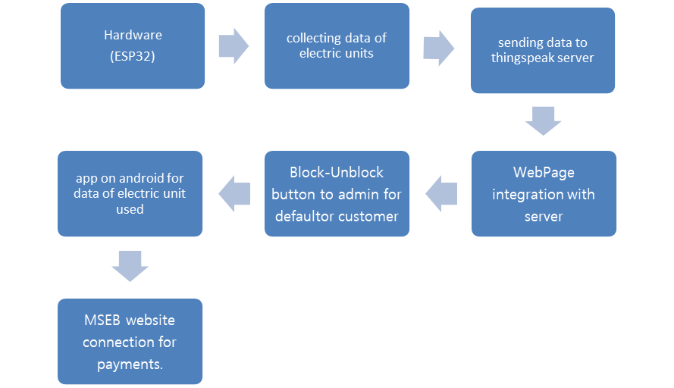

**Fig. 1: work flowchart**

**Website implementation**

For customers we create a website , This website has three tab first is home screen ,second login page , third energy calculator page . after customer login website they can see their profile page. In this profile page we include their consumption of electricity mean billing units and customers consumption graph . This profile page is connected to server (thingsspeak). Server receive data from hardware and send to our website .For website we use HTML,CSS,php .

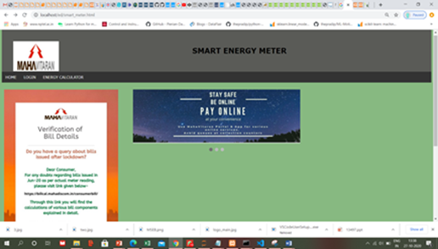

**Fig. 2: website**

**App implementation**

The working application for data result ,This app part of the project in which a application for android device which can directly show the units used from thingspeaks server , the purpose behind the app to ease the user experience through this application .

Process of application

* This is only android application
* After installing this application
* This application takes the result reading from thingspeak server and present it on application in numerical format
* As thingspeak has unique api key , therefore applying this key in application , gives the specific result.

Advancement

This app can give the units used and show the approximate amount of electricity bill

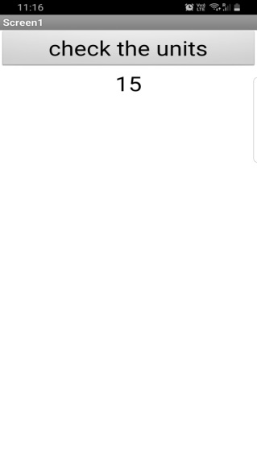

**Fig. 2: App showing data of consumed electric units**

**Conclusion and Future Scope:**

This paper describes the design and working of Smart Energy Meter and represents how Smart Energy Meter can be used for Automatic Meter Reading. It is the most economical implementation to develop mankind in this era of technology. With the present enhancement in the use of technology to facilitate mankind, it is an efficient and practical utilization of present networks. This paper also shows that how customer can manage the load by using Smart Energy Meter. It provides ease in taking the meter readings, User can see their account how much they consume .so the process of electricity bill unit collection then processing and send to customer is omitted now ,also detection of faulty conditions, power factor calculation can possible & less operation cost and removal of possible corruption related to meter reading.

**References:**

Shaadi.com, 2009, Available at: http://www.shaadi.com (accessed on

18

th

July 2009).

[1] <https://circuitdigest.com/esp32-projects>

[2] <https://www.instructables.com/ESP32-SIM800L-and-Barrier-Sensor/>

termediaries in the marriage market: A typology

and review. Journal of Marriage and the Family,

54(2), 452-463.

[3] <https://thingsboard.io/smart-metering/>

[4] <https://randomnerdtutorials.com/esp32-esp8266-mysql-database-php/>

[5]<http://www.appinventor.org/>